**Name:** Jaydeep Solanki

**Roll:** 22BEC059

**Practical 7:** Write a program for predicting selling price of houses in Boston dataset using KNN regressor

1. Using SkLearn Library.

import pandas as pd  
from sklearn.metrics import mean_absolute_error, mean_squared_error  
from sklearn.model_selection import train_test_split  
from sklearn.neighbors import KNeighborsRegressor  
  
data = pd.read_csv("BostonHousing.csv", header='infer').values  
  
x = data[:, 0:-1]  
y = data[:, -1]  
x_train, x_test, y_train, y_test = train_test_split(x, y, test_size=0.3)  
k = int(input("Enter the nearest neighbor number(k) : "))  
  
model = KNeighborsRegressor(n_neighbors=k, weights='distance')  
model.fit(x_train, y_train)  
pred = model.predict(x_test)  
mae = mean_absolute_error(y_test, pred)  
mse = mean_squared_error(y_test, pred)  
print("Using Sklearn: ")  
print("MAE: ", mae)  
print("MSE: ", mse)

Output:

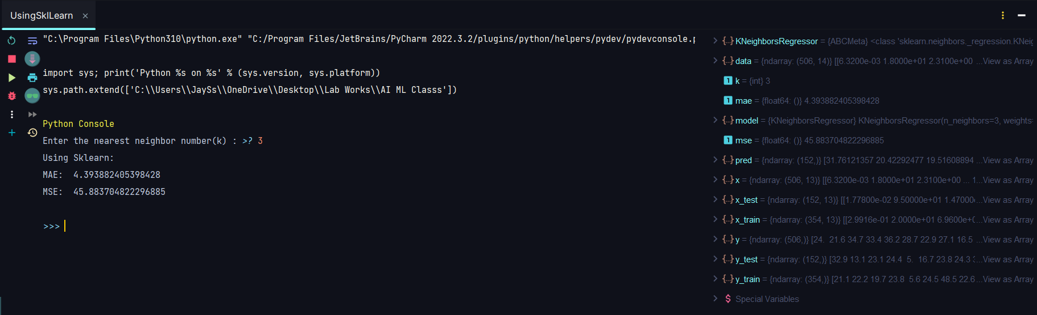

1. Without using SkLearn Library

import numpy as np  
import pandas as pd  
from sklearn.model_selection import train_test_split  
from tabulate import tabulate

def MAE(pred, y_test):  
 return np.mean(abs(pred - y_test))  
  
def MSE(pred, y_test):  
 return np.mean((pred - y_test) ** 2)  
  
def RMSE(mse):  
 return np.sqrt(mse)  
  
def MAPE(pred, y_test):  
 return np.mean(abs(pred - y_test) / y_test)  
  
def KNNRegressor(k):  
 data = pd.read_csv("BostonHousing.csv", header='infer').values  
 x = data[:, 0:-1]  
 y = data[:, -1]  
 x_train, x_test, y_train, y_test = train_test_split(x, y, test_size=0.3)  
 nClasses = np.unique(y_train).shape[0]  
 distance = np.zeros(shape=x_train.shape[0])  
 pred = np.zeros(shape=x_test.shape[0])   
 for i in range(x_test.shape[0]):  
 distance = np.sqrt(np.sum((x_train - x_test[i]) ** 2, axis=1))  
 kMinIndex = np.argpartition(distance, k)[0:k]  
 invDist = 1 / (distance + 10e-20)  
 Denom = sum(invDist[kMinIndex])  
 pred[i] = np.dot(invDist[kMinIndex] / Denom, y_train[kMinIndex])  
 return [MAE(pred, y_test), MSE(pred, y_test), RMSE(MSE(pred, y_test)), MAPE(pred, y_test)]  
  
display = {}  
n = int(input("Enter the number of 'k' till which you have to compare: "))  
for i in range(1, n+1):  
 ans = KNNRegressor(i)  
 display[i] = ans  
  
print(tabulate(pd.DataFrame(display).T, tablefmt="pretty", headers=["MAE", "MSE", "RMSE", "MAPE"]))

Output:

